**CRUD Application  
 (Spare Mate Admin)**

* The project will be divided into **two parts:**

1. **Admin (crud)**
2. **Client**

* Admin site will be used for adding / updating / deleting products from the database.
* Client side will be used by the customers to browse and purchase products.

The entire web application will be built on python flask framework and will use Postgre database for storing information.

**Admin Site**

* The admin site is basically the page where the admin can add delete or update products, brands and categories.
* Admins can edit the page as per their needs.

**Login Page**

* The admin will use his/her credentials such as email and password to login.
* This is the landing page.

**Navigation Panel**

**Navigation panel will consist the following tabs:**

* **Login tab:** This page will consist of two textfeild email and password.
* **Edit tab:** Through this admin will get the access to edit the products, like add products, add brands, add categories.
* **Add tab:** This will provide option of adding products, brands and categories.
* **Product:** Overview of entire database.
* **Logout:** This admin can use to logout from his/her account.

**Product**

Under **“Product”** following categories would be added.

* Admin can see the entire database.
* Admin can edit or delete the products, brand and categories.

**Categories inside add product form**

* The main product form will include the name of the products to be added along with the price of it and, if available, the discounts associated with the pricing.
* The available stocks will be added. The colors of the products will be added. Manufacturer information will be included in the form along with the different categories with a well-detailed description.
* 3 images can be added, although adding 1 image is compulsory. The certificate for confirming the authenticity of the product will also be added for user satisfaction.

**Database for Admin Side**

**Admin Side will consist of the following tables.**

* Products
* Admin
* Brands
* Category
* This database will be used for storing the admin credentials and product details. The credentials like name of the admin, his/her username, email and password will be stored in the database.
* The product details such as name of the products to be added along with the price of it and, if available, the discounts associated with the pricing. The available stocks will be added. The colors of the products will be added.
* Manufacturer information will be included in the form along with the different categories with a well-detailed description. 3 images with an authentication certificate.

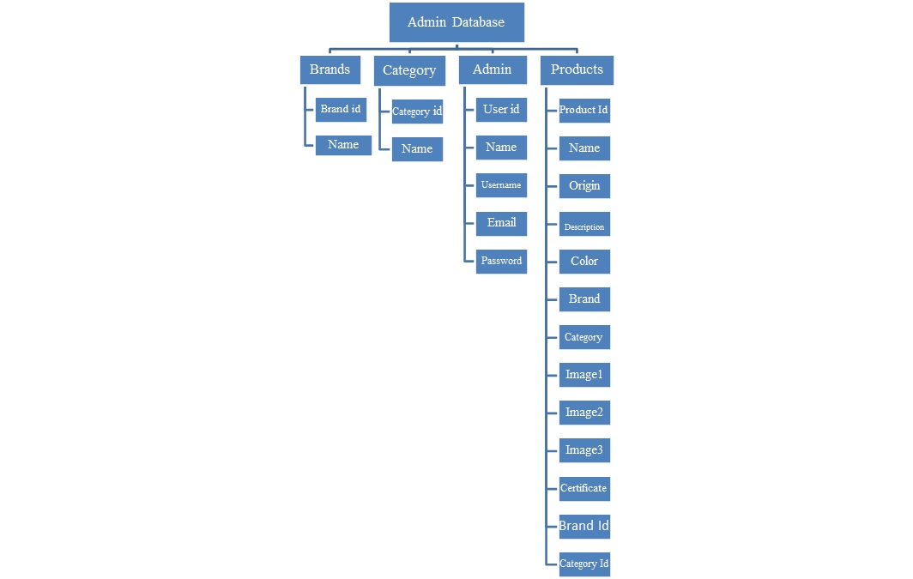

**Database** **Description**

* Product Id, Brand Id & Category Id in the table product will be primary key, Foreign key respectively
* Brand Id will act as primary key in the table Brand
* User Id will act as primary key in the table User
* Category Id will act as primary key in the table Category.

**Updating/Deleting products, brands and categories**

* Admin has the authority to update and delete products from the database. Any products which need to be edited or updated with the changes need to be done by the admin for transparency to users.
* Deleting the brands will also delete all the products linked with the brand.
* Admin should be able to update or delete products from the main page. So, similarly, the brands and categories also can be updated.
* Update product form should be able to retrieve information from the database when clicked on particular products.
* However, the image fields can be optionally updated as previously updated image need or need not be updated.
* Brands and categories can be fetched with the barcodes/ID associated with the products. This may come in handy when the admin is updating or deleting a particular product or brand.
* Database query needs to be run in order to fetch a brand or category and similar logic to be used for fetching products.

**Security Measures**

* Admin will have to login with his/her registered credentials only.
* Passwords stored in the database will be secured, using hash function.
* If the user is inactive for more than 5 minutes. The session will time out, and the admin will have to re-enter the credentials to login.
* Without login in nobody can access the admin panel.
* Email notifications will be sent when the admin logs in. The mail will include Email of the user, Login timestamp and the date.

**Additional Features**

* In case admin wants a hardcopy of the inventory. There will be a print inventory button to do so.
* The hardcopy will be in PDF form which will contain the date and the timestamp of the product when added.

**ER & Functionality block diagrams**

